
APPLICATION
DEVELOPMENT THEORY 4
Architectural Design for the Tourism System
Term 2 Assignment 3

Group Members:

No. | Surname and Name | Student Number
1 | Kabai Moipone | 2 | 1 | 5 | 2 | 0 | 3 | 5 | 6 | 9
2 | Msomi Sebe | 2 | 1 | 6 | 0 | 2 | 8 | 6 | 0 | 4

Due Date: 13 July 2020
4+1 View Model
Views | Description
Logical view | The logical view is concerned with the functionality that the system provides to end-users. So, our tourism system allows the tourists to interact with it by entering their login details. The system is user friendly and allows the tourists to interact with it without struggling to find things. For example, tourists do not have to search in hidden places for buttons that will take them to the accommodations, activities or favourite pages. The buttons are clearly labelled in the welcome screen where they are visible for anyone to click. We added the favourites screen to reduce chances of the user having to search from scratch for the places they like and might happen to want to visit again. This will help them save those places in their favourites so that they can easily access them anytime they want to. We reduced typing errors by making use of the GUI items that require simple clicking to make selections.
Process view | A process view shows how the system is composed of interacting processes. In our tourism system, when the tourist enters their loin details, the application will trigger a validation process where it checks through the system’s database if the user is registered. If they are not, they will not be able to login as they are not recognized by the system. This will require them to register their details to the system so they can be able to login afterwards. However, if the user is registered, but enters the incorrect login details, username and password, they still will not be able to login to the application until they enter the correct details. They can still be able to change they password if they forget it through the link that will be sent to the email address verified through registration after clicking “forgot password” hyperlink. The connection here is that the database communicates with the GUI in verification of the user details.  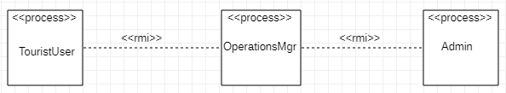
Development view | A development view shows how the software is decomposed for development, showing the breakdown of the software into components that are implemented. We represented this view in the structure below.  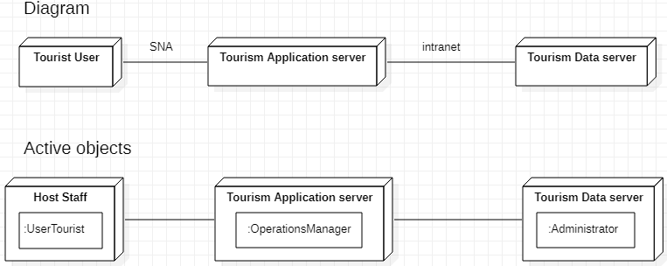
Physical view | A physical view shows the system hardware and how software components are distributed across the processors in the system. Our system allows every user to login to the system using any device with the application installed in it. It can be a PC, PDA, laptops, smartphone, etc. and the page directs them to their respective profiles after logging in depending on their identity captured in registration. These devices will have to be connected to the internet so that they will be able to navigate through various screens and also direct the user to the main website of the accommodation, which includes restaurants, or activities. This system allows disturbances outside the application like calls, messages and any other day-to-day functionality experienced by a user in any other application. It will not block any other functionalities because it is functioning on the same device. This will help the user to also continue with other things on the device, and not only be restricted to the system when they are logged in.
Scenario(s) | The description of an architecture is illustrated by using a small set of use cases or scenarios. The scenarios are used to identify architectural elements and to illustrate and validate the architecture design. They also serve as a starting point for tests of an architecture prototype. For our system we used the use case scenario of the tourist user as follows:  Use case name: Tourist (User) views the accommodations that are recommended as safe by the system.  Scenario: User views each accommodation they are interested in.  Triggering event: User wants to select the safest accommodation for their safety.  Brief description: User books the accommodation by clicking the hotel they want which will direct them to the main website of the hotel.  Actors: Tourist  Related use cases: Tourist clicks the ‘Safest Accommodations’ button  Stakeholders: Tourist, Tourism system  Preconditions: The user must select the ‘Safest Accommodations’ button on the welcome screen. Accommodations must be displayed on the related screen  Post conditions: User is directed to the accommodations screen by the system. User selects the accommodation desired  Flow of activities: Actor System  - User clicks the ‘Safest Accommodations’ button - User adds the accommodation to Favourites - The system directs the user to the accommodations screen 2.1 The system saves the item into Favourites and displays it there  Exception conditions: - User does not click the accommodations button 1.1 User clicks the other buttons in the system 2.1 User did not add the item to Favourites.

